Midterm Project Report
Supervised Learning - 2024-2025
Project Topic: Analysis and Prediction of Weight Loss in Subjects Undergoing Diet
Student Name: [Sergio Fernandez Diz]

The dataset used in this project consists of 14 features (9 numerical and 5 categorical) with a total of 600 rows (samples). The target variable is "Final Weight (lbs)".
- Processing data
- Symbol ‘-‘: In the dataset, the symbol ‘-’ was present in the Smoke and Gender features. For Smoke, the symbol was replaced with 'NO' since only the value 'yes' was present, indicating that the symbol likely meant 'NO'. For Gender, the symbol was replaced with NaN to avoid introducing biases. The analysis suggested that the dataset was divided into male and female, but to be cautious, these entries were marked as NaN.
- Outliers/Missing Values: In the dataset, a small number of outliers were identified. After analysis, these were replaced with NaN. Specifically, 10 outliers in the 'Age' feature were identified as noise (values around 200 or negative). The remaining 5 outliers were also set to NaN to avoid negatively impacting the model's performance.
- Correlation analysis: For this analysis, a heatmap was first plotted to visualize the correlation between the features, revealing 2 significant correlations. To further analyze the correlation between the features and the target variable, a series of scatter plots were used. These plots showed that BMR (Calories) has a very strong correlation with the target, indicating its importance for training our models.
- Features Distribution: The PDF analysis of the features revealed that most numerical features followed a distribution similar to a Gaussian, except for "Daily Calories Consumed", which showed a left-skewed distribution. To make this feature more Gaussian-like, the following transformations were applied: first, an inversion 1/(x+1) was applied, followed by a log transformation. This did not produce a normal distribution, bat was retained trasformed because improve the performance of the final models.For the categorical features, a potential issue was identified with "Sleep Quality", where the "Excellent" category had only about 20 entries. This small sample size could lead to generalization issues for the model. To test this, "Excellent" was combined with "Very Good," but this resulted in worse model performance, so the original categories were retained.
- Scaler features: To improve the dataset, scaling was applied to all numerical features. Specifically, a Min-Max scaler was used for the 'Daily Calories Consumed' feature since it does not follow a normal distribution and is very good for knn imputation, while a Standardization scaler was applied to the rest of the features due to their symmetric distribution.
- Encoding features: A total of three types of encoding were used: Binary encoding for the features 'Gender' and 'Smoking'; Ordinal encoding for 'Physical Activity Level' and 'Sleep Quality' since they follow a specific order; and One-Hot Encoding for the 'Work Sector' feature, which does not have any inherent order.
- Features Selection: For feature selection, three methods were used: Univariate (SelectPercentile) with a 50% threshold to reduce model complexity, Iterative (RandomForest) selecting the top 7 features, and Model-Based (Linear Regression). To combine these methods, only the features present in at least two out of the three were kept. This resulted in a final set of 7 features.
{'Age_scaled', 'BMR_scaled', 'Daily_Caloric_S/D_scaled', 'Daily_Calories_Consumed_scaled', 'Duration_scaled', 'Gender','Weight_Change_scaled'}
- Analisys Results:
The project involves processing a dataset to optimize it and then developing a series of models to predict the Final Weight (lbs) feature. A total of 5 models were developed: Linear-Regression using Sklearn, Batch Gradient Descent, Mini-Batch Gradient Descent,Linear Model with Lasso Regularisation and Ridge Regression Model. Additionally, some of these models were tested on different datasets. The main dataset was first split into two parts: one including the BMR feature and one excluding it. It was further divided based on gender (male and female).
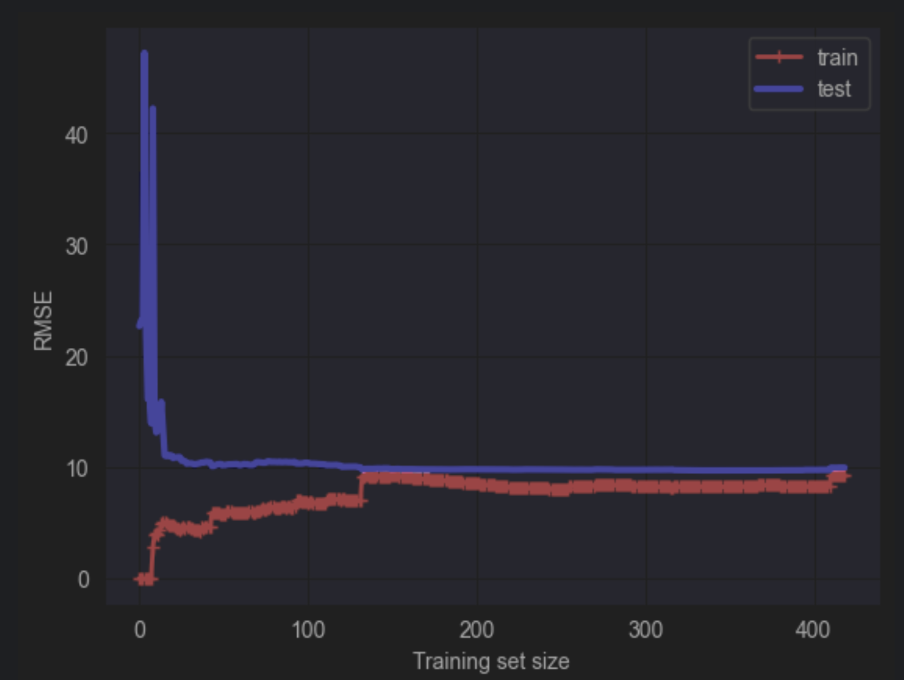
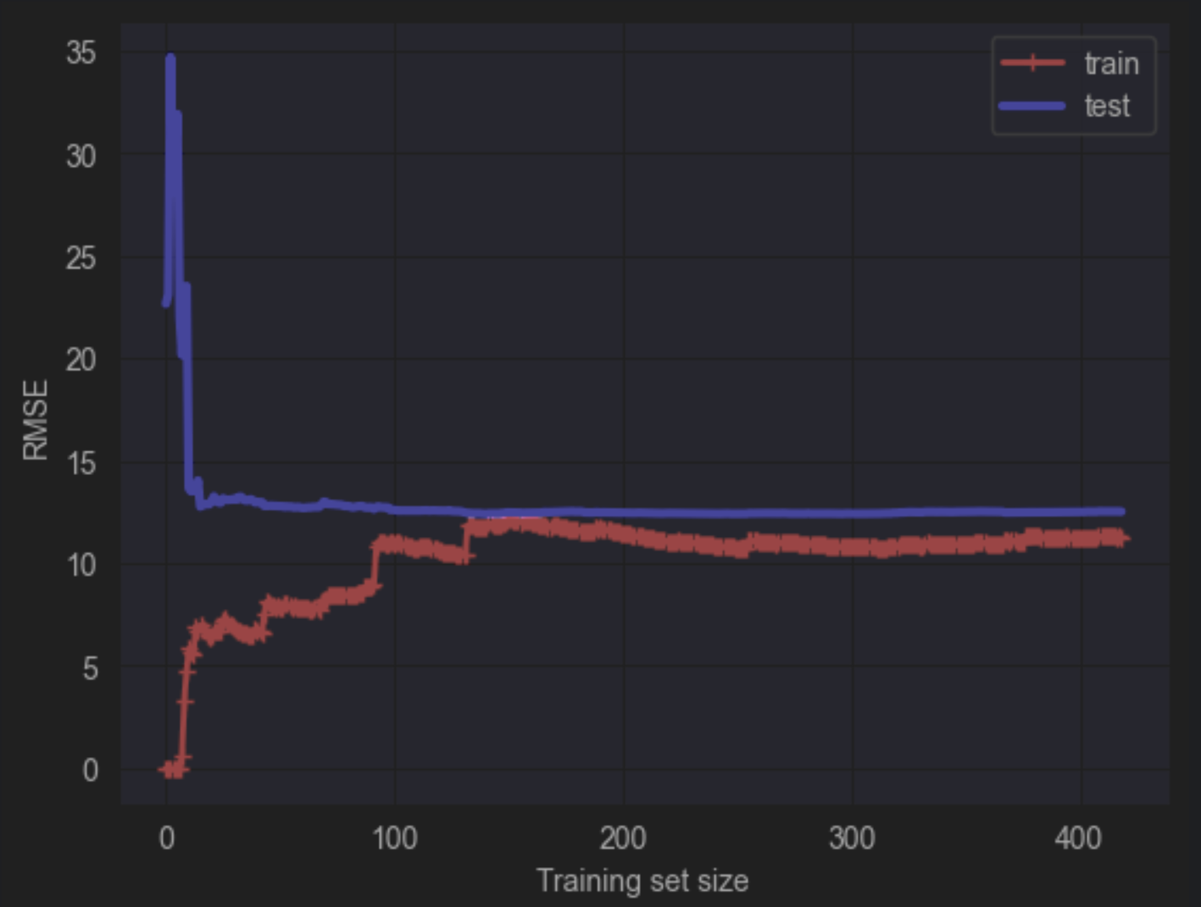
- Linear Regression with Reduced_dataset: With BMR
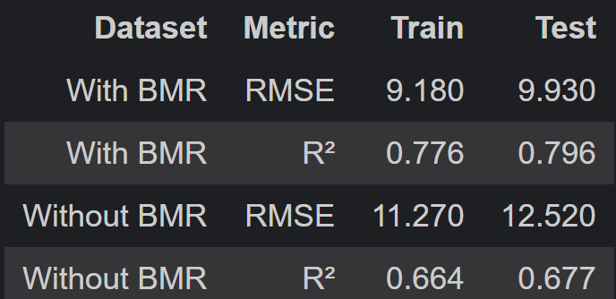

Analyzing these values, we can observe that the model using the BMR feature has a lower RMSE and a higher R², indicating better performance and generalization. This improvement can be attributed to the fact that the BMR feature has a strong correlation with the target variable, as identified during the dataset processing. Analyzing the two learning curves, we can observe that both models generalize well and are not subject to underfitting or overfitting. This is evident as the test error decreases while the train error increases as the training set size grows.
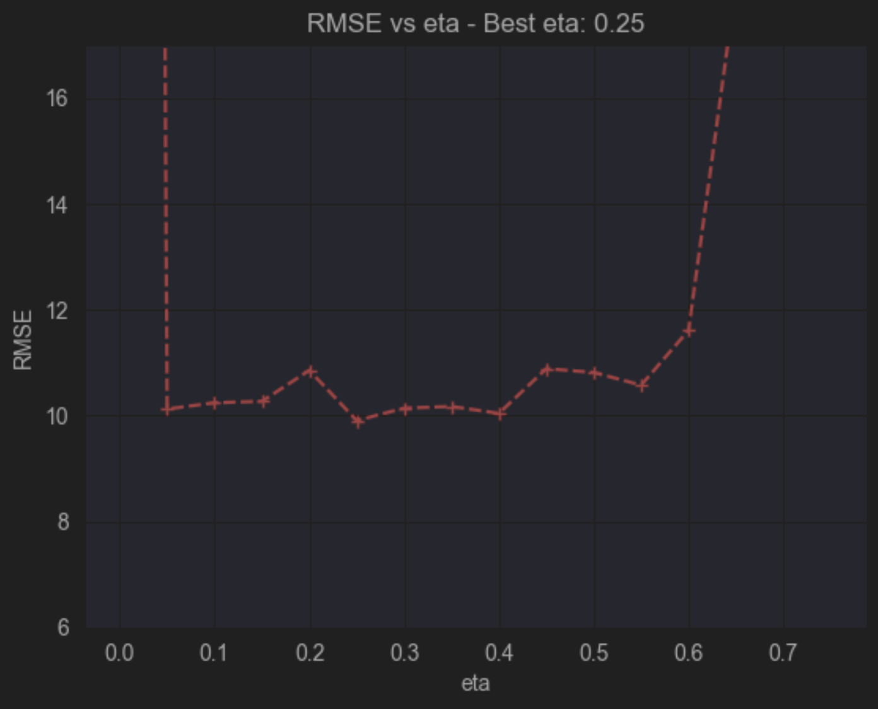
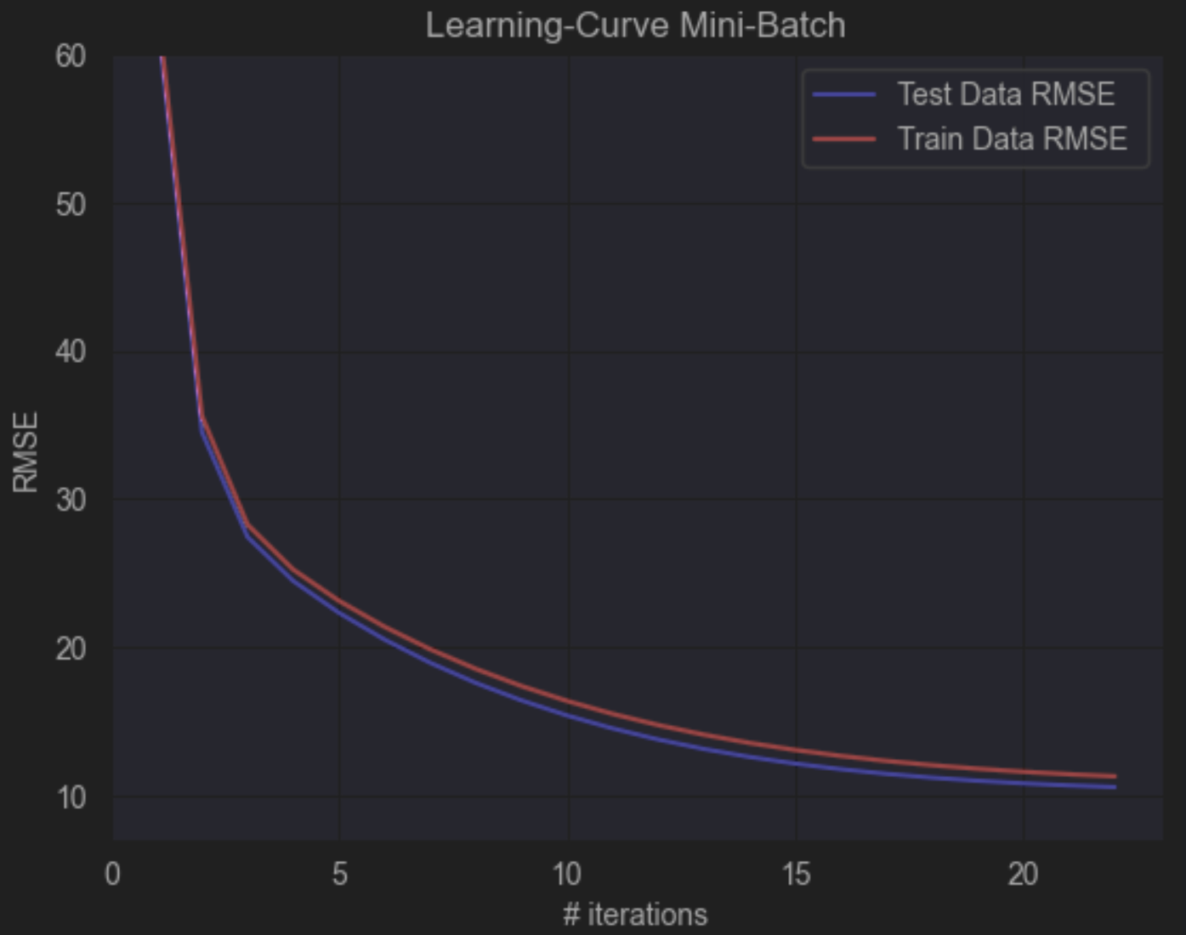
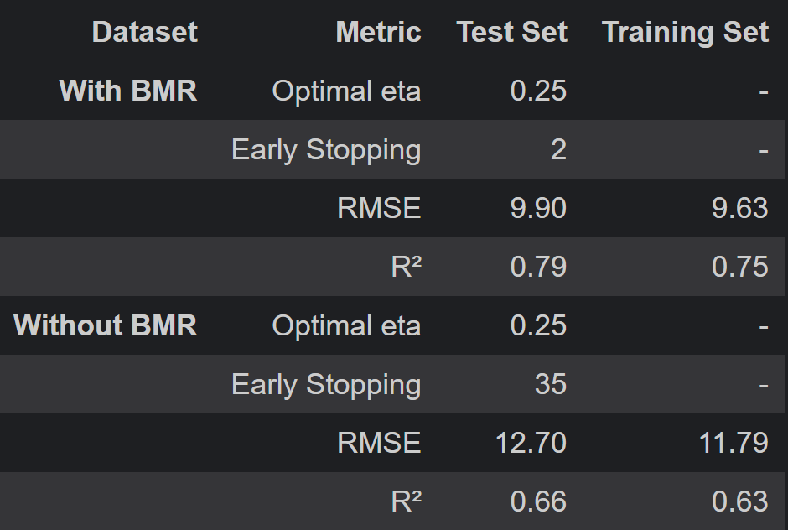
- Mini Batch Gradient Descent Reduced_dataset: With BMR

We can observe how the optimal 'eta' (learning rate) is found during training. As seen in the graph, the RMSE value fluctuates up and down, which is typical of the Mini-Batch Gradient Descent method.
Regarding the learning curves, we can conclude that the model is functioning correctly without signs of overfitting or underfitting:
Underfitting occurs when both the training and test errors start increasing together.
Overfitting is indicated when the test error decreases while the training error increases.
As for the performance metrics, we can see that excluding the BMR feature results in a slightly worse model, as evidenced by the increased RMSE and decreased R² values.Another observation is that the training curve is above the test curve, which could be due to the random split of the data into X_train and X_test. This can occasionally lead to a training set that is slightly easier to predict than the test set, depending on how the split is performed. For the dataset without BMR, the graphs are similar but have different values.
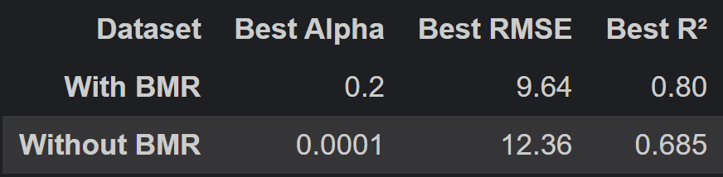
- Linear Reg. with Lasso Regularization aumented_dataset:
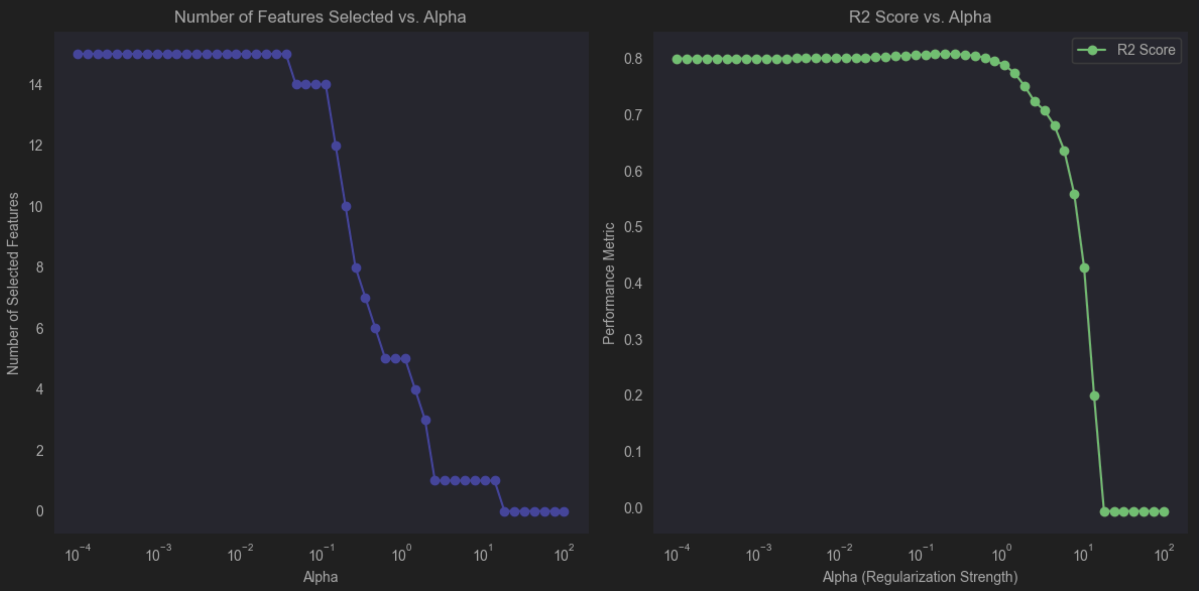
The analysis conducted using Lasso regularization on datasets, with and without BMR, reveals significant differences in performance.
With BMR, the model achieves an optimal alpha of 0.2, reducing the RMSE to 9.64 and reaching an R² of 0.80. This indicates that BMR effectively enables the model to eliminate irrelevant features, maintaining high accuracy while reducing complexity.
In contrast, without BMR, the model requires a very low alpha (0.0001) to achieve the best performance, resulting in a higher RMSE (12.36) and a lower R² (0.685). This suggests that, without BMR, the dataset contains many irrelevant or redundant features, making the model less robust to regularization.
In summary, the use of BMR allows for better regularization, reducing the number of features without compromising accuracy, whereas without BMR, the model becomes more complex and less effective.
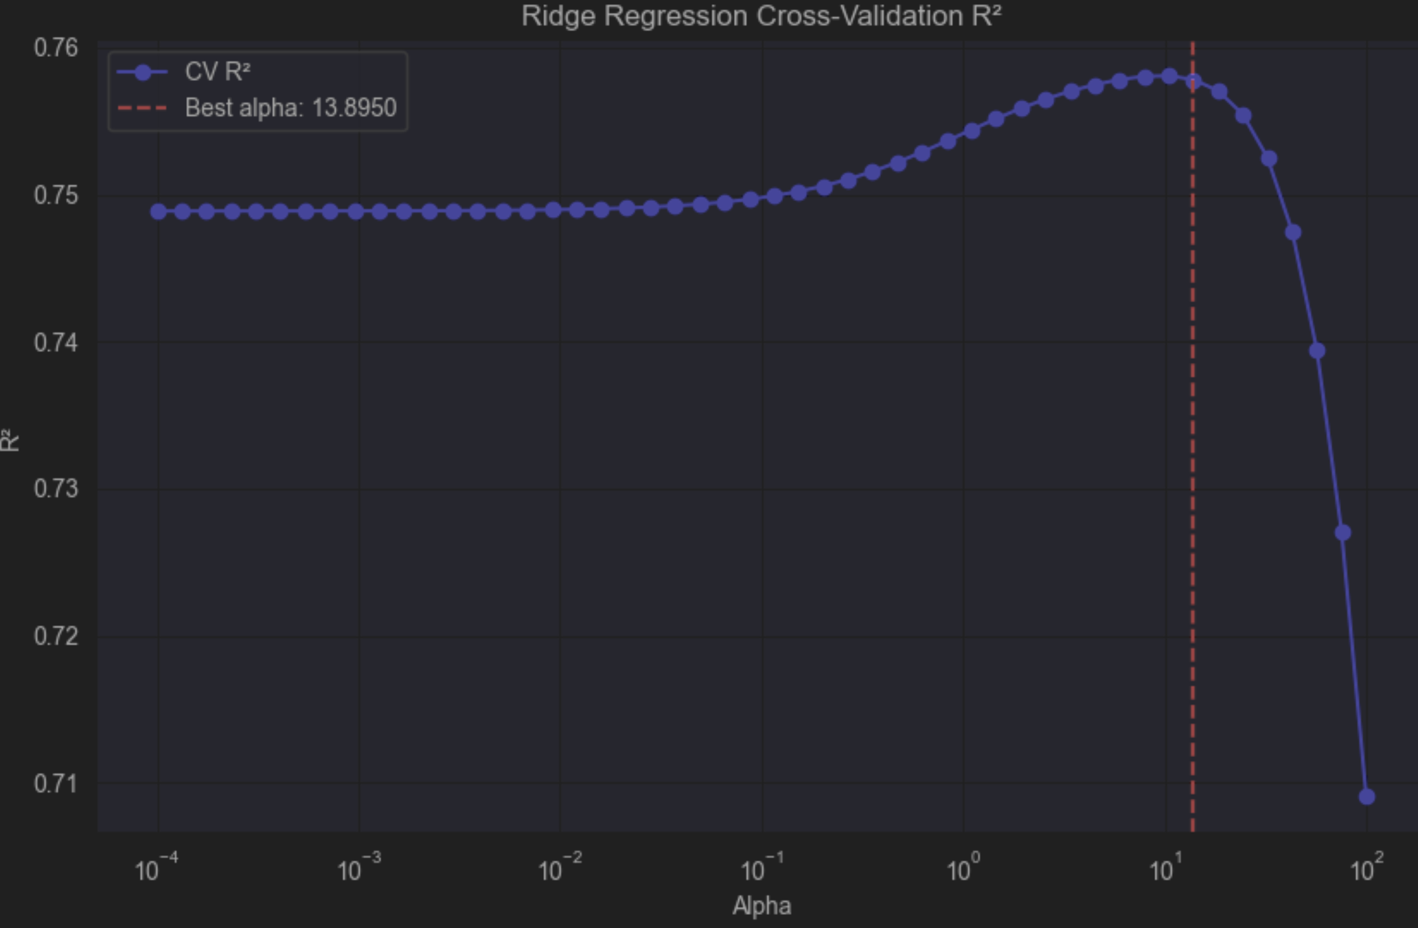
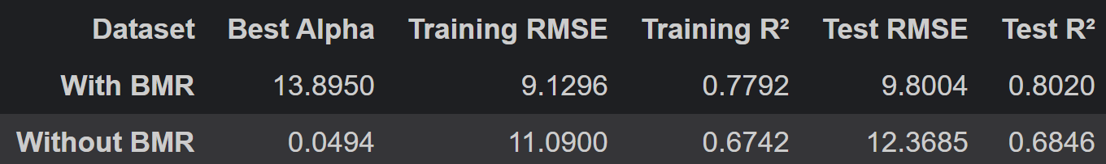
- Ridge Reg. Model aumented_dataset:
A plot was created for the R² of the Ridge model to show how well the model explains the variability in the data.For low alpha values, the R² remains constant around 0.75. As alpha approaches 1, the R² starts to increase, reaching its optimal value before dropping sharply.
Explanation of the Trend
- For low alpha values, there is minimal regularization, so the model behaves like standard linear regression.
- As alpha increases, moderate regularization helps reduce overfitting, improving R² by allowing better generalization.
- Beyond a certain point, high alpha values over-penalize the coefficients, leading to underfitting. This is why the R² drops sharply.

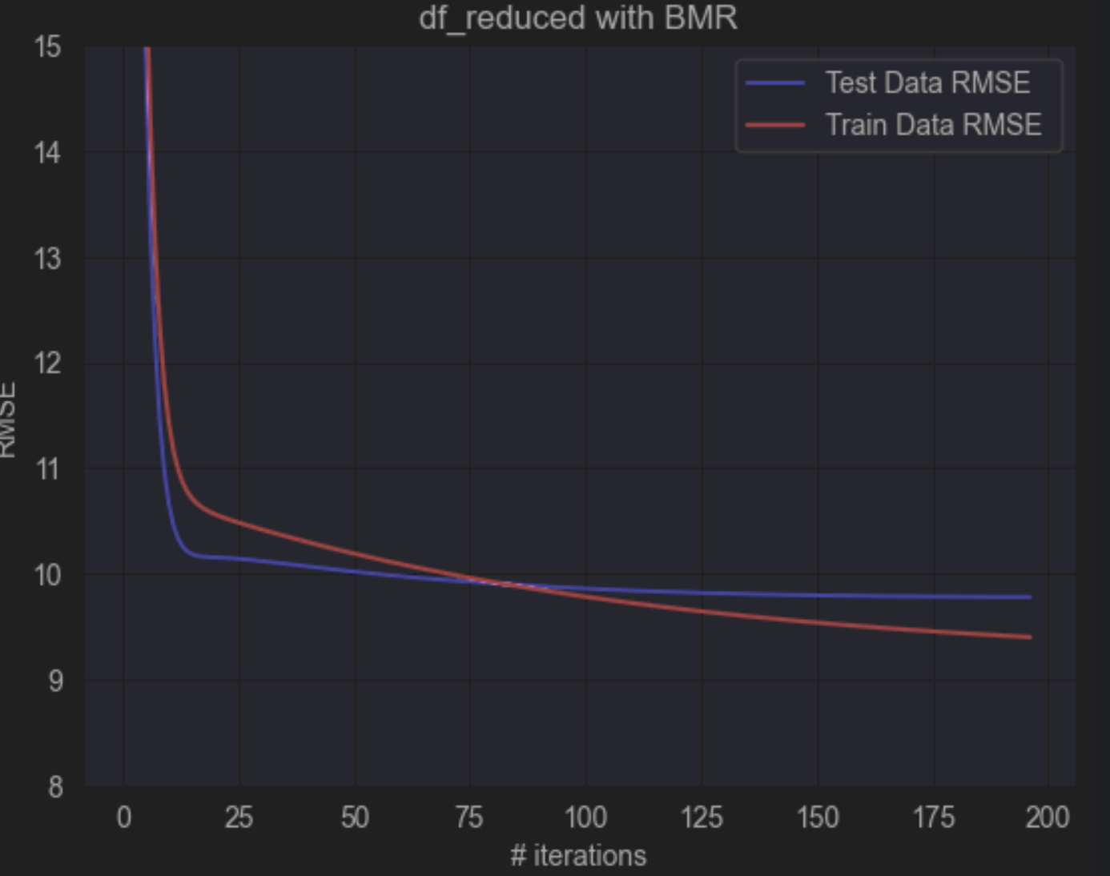
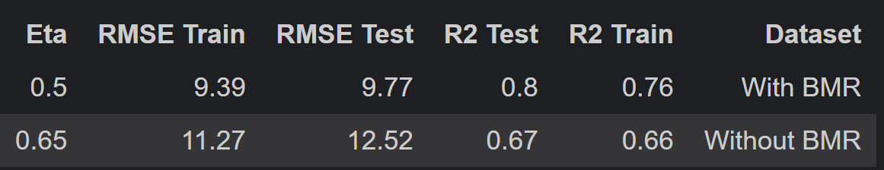
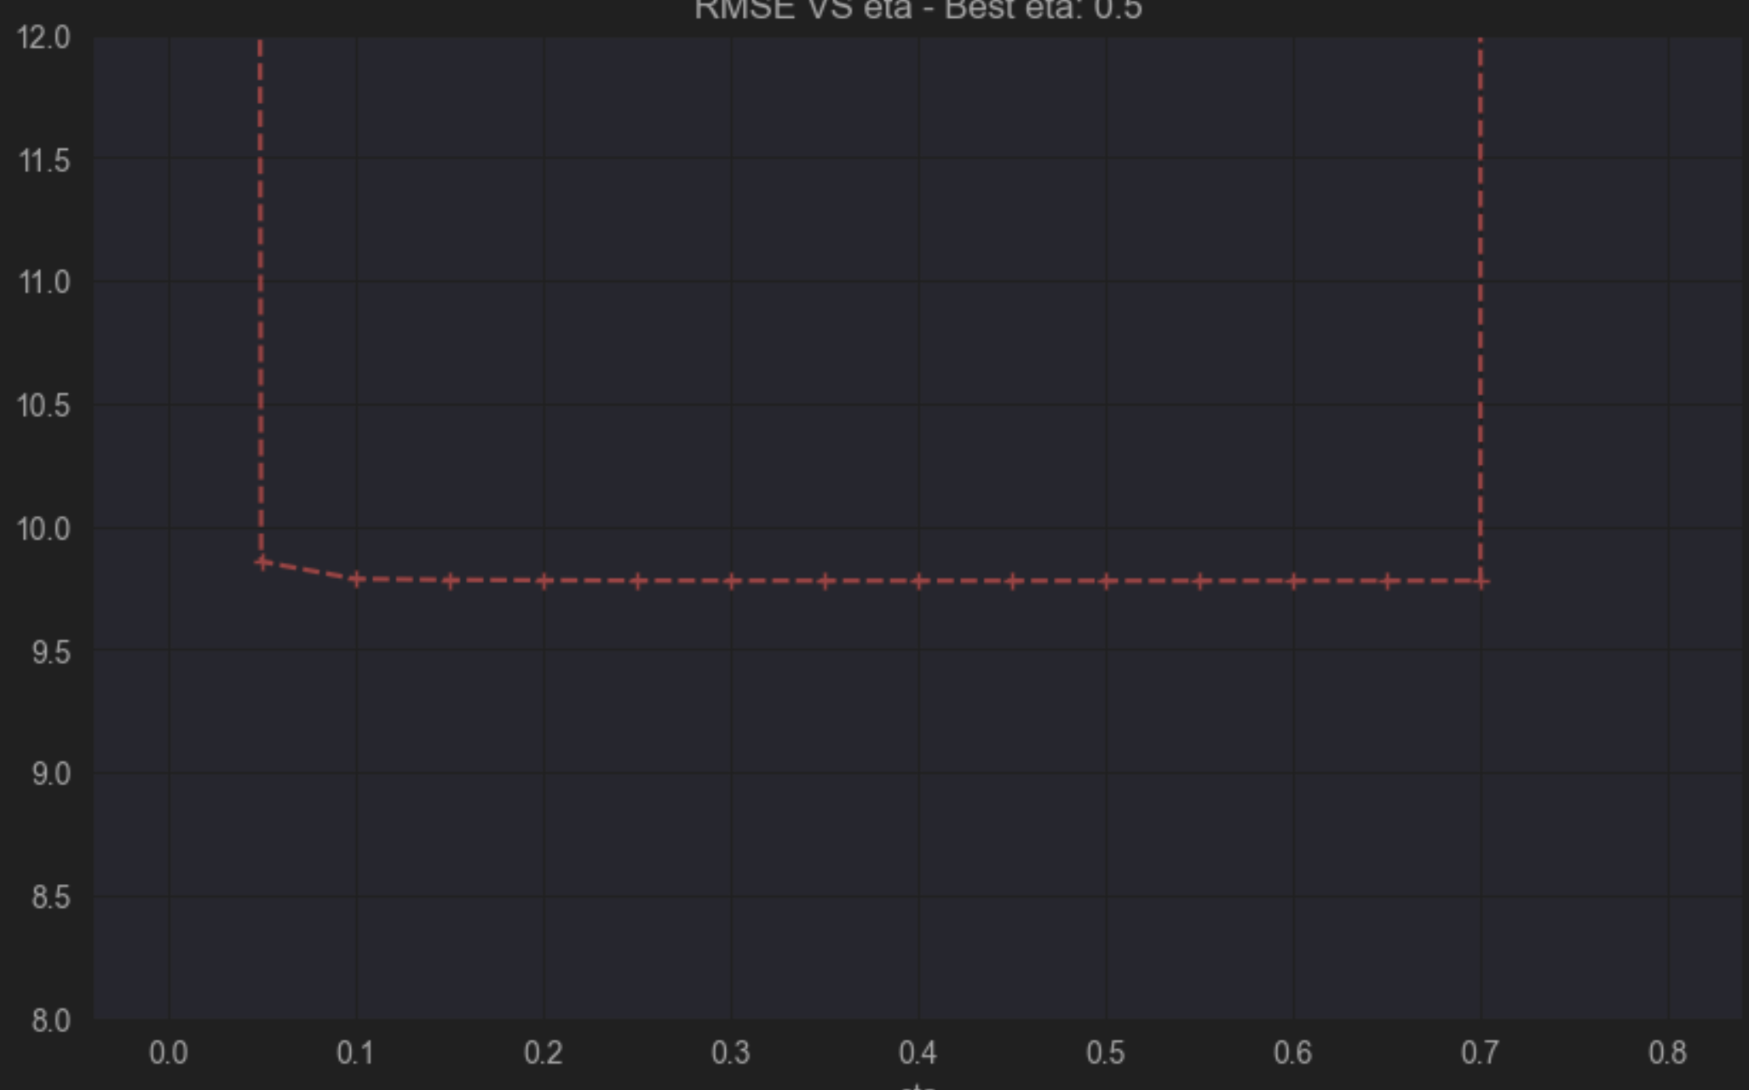
- Batch Gradient Model reduced_dataset:

The learning curve shows the RMSE for both the training (red) and test (blue) sets over iterations. 1. Rapid initial convergence: Both curves decrease quickly in the first 20-30 iterations, indicating the model is learning effectively. 2. Stable convergence after ~50 iterations: The curves flatten out. 3. Small gap between training and test curves: This indicates good generalization. 4. Asymptote around RMSE 9-10: The model reaches its performance limit, with little improvement beyond this point.

- Final Results: The final analysis involves comparing the different models applied to the reduced dataset, which are trained on various subsets (Female without BMR, Female with BMR, Male with BMR, Male without BMR) to understand how these modifications affect model performance. To achieve this, several plots and tables were generated:
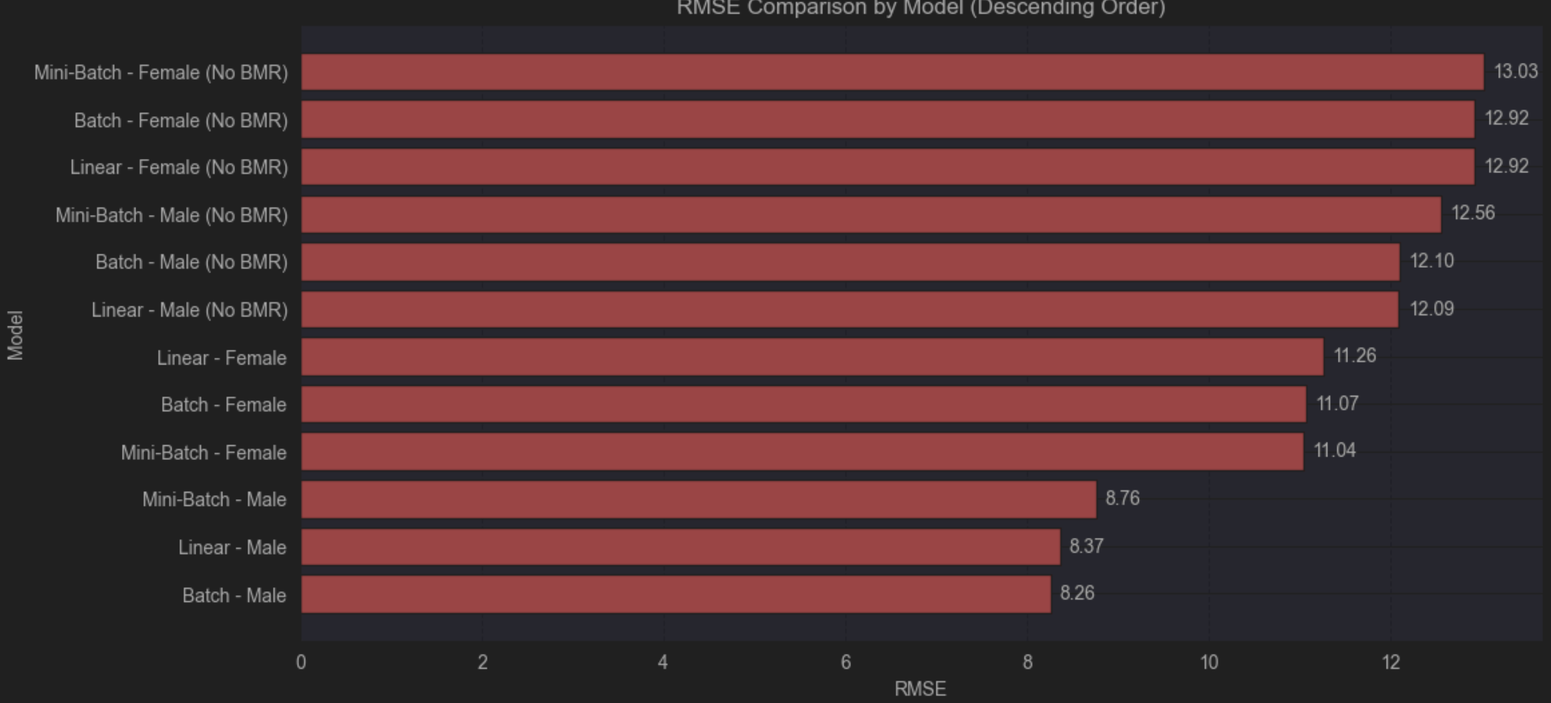
From this bar plot, we can identify which specific models perform better by analyzing the RMSE. As observed, the top performers are Batch-Male and Linear -Male. Another key observation is that all models without the BMR feature perform worse compared to those with it. Additionally, the the models for Female perform worse compared to Male. This is probably because the dataset of male have more general aspect and complet information.

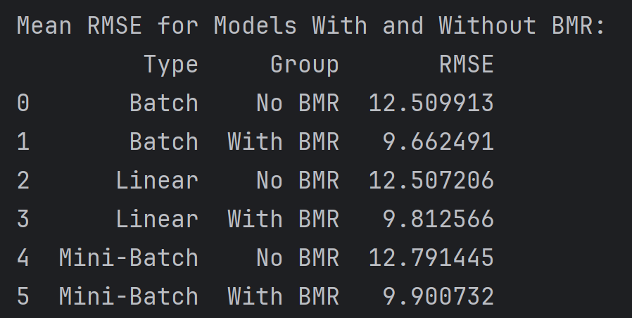
The key aspect to analyze here is the average performance of the different models by combining the RMSE for Female and Male. The results indicate that, for the Batch and Mini-Batch models and Linear, training separate models for males and females, applying these models to y_f and y_m, and then merging the results can lead to improved model performance (points (a), (b), (e)).

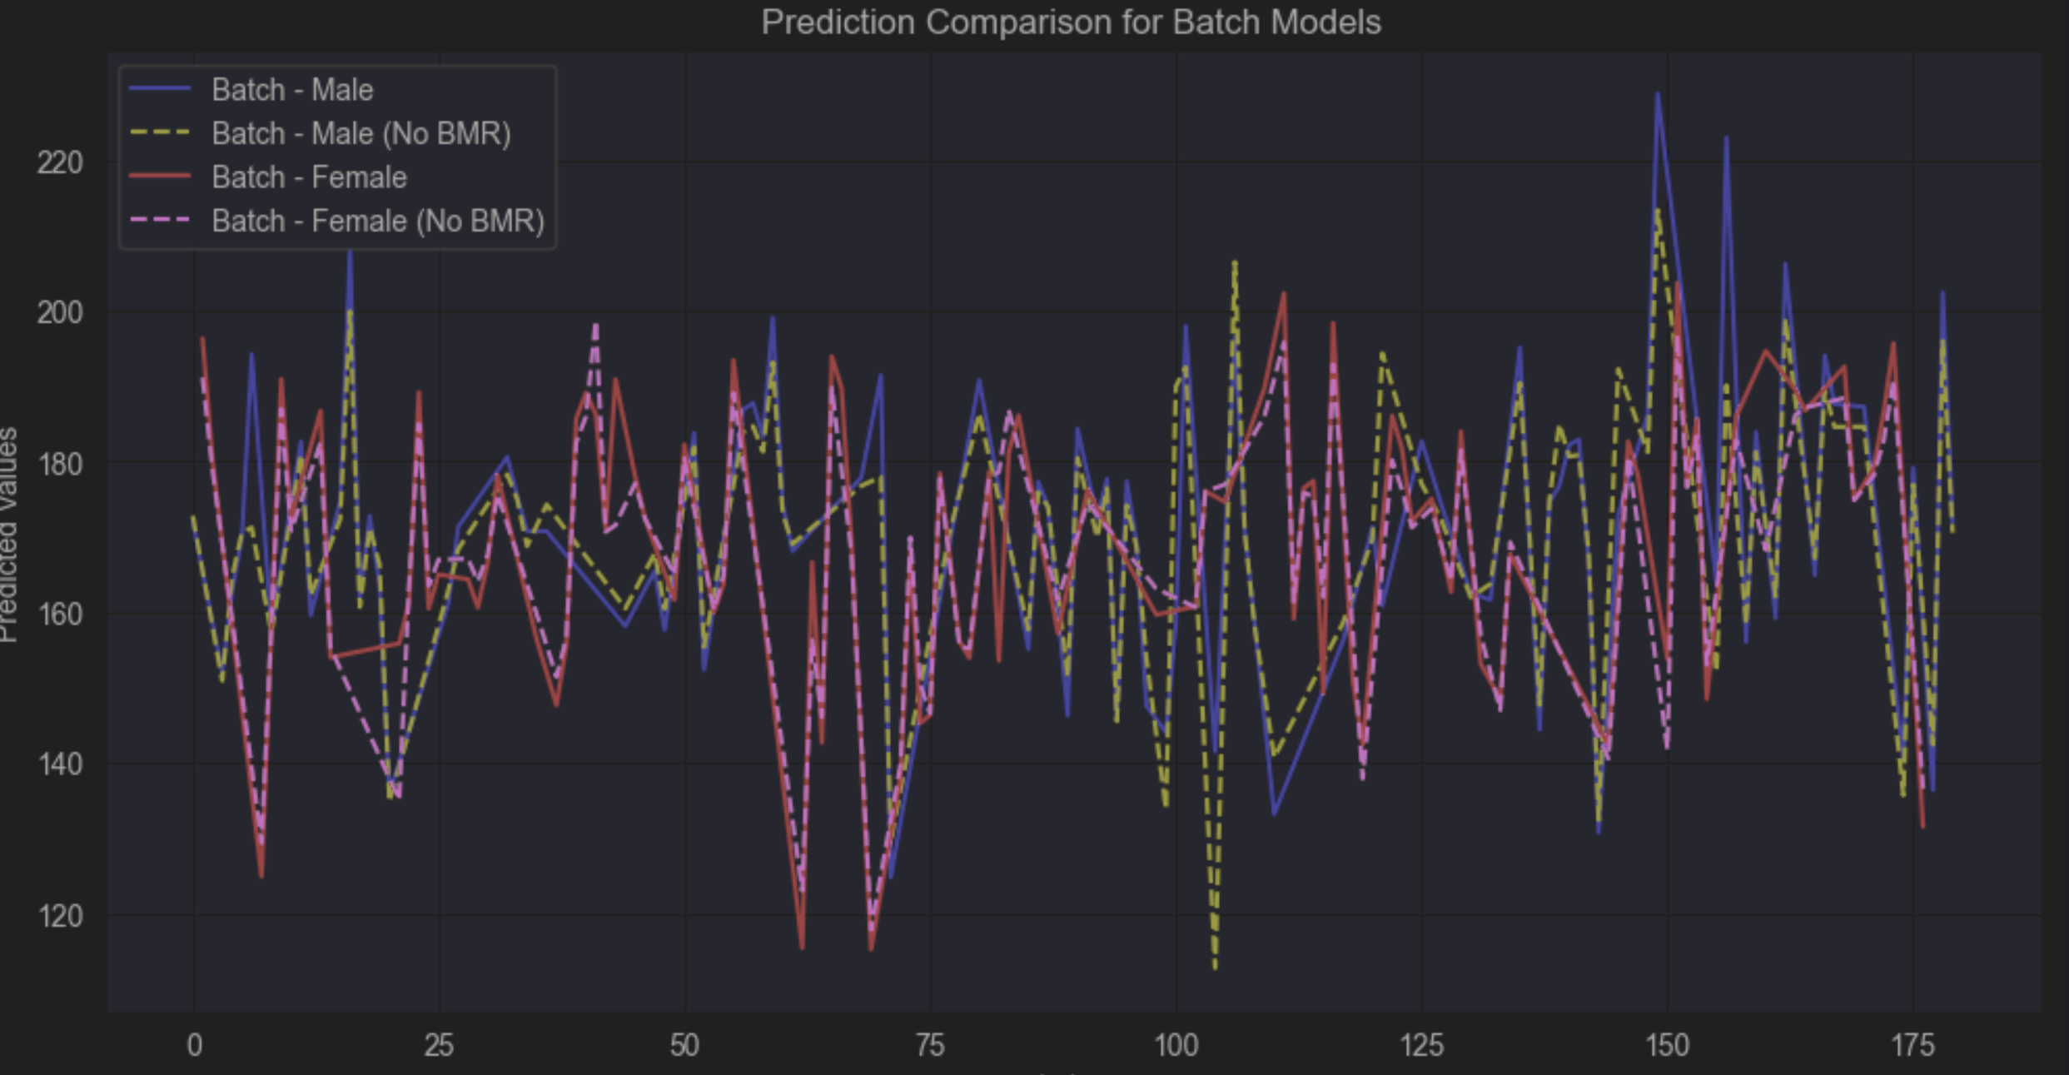

This plot shows the different y_pred values, allowing us to make some observations. The plot was created for the three different models, which display a very similar pattern across the four lines. This indicates that the models predict the various samples in a similar manner. However, what changes is the type of dataset used for training. As observed in the plot, predictions vary depending on whether the BMR feature is included and based on gender, which impacts the model's predictions.

